C:\Documents and Settings\clamport\Local Settings\Temporary Internet Files\Content.Word\bscsd header.tif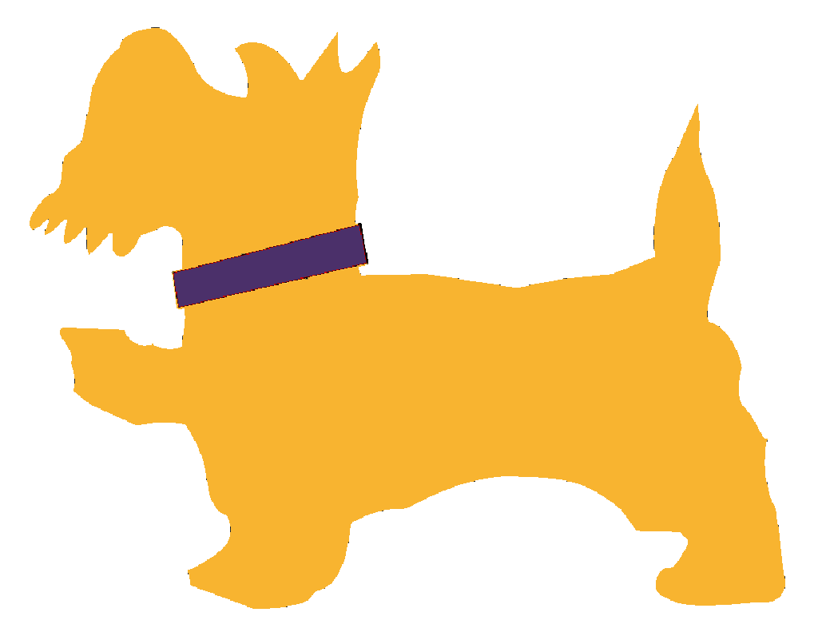



**Home of the *Scotties!***

**Suburban Scholastic Council**



**Save the Date!**

The Ballston Spa CSD offers two districtwide family events   
during the school year including:

**The Ballston Spa Fall Family Festival**

**Saturday, October 21, 2017  
10:00 a.m. to 3:00 p.m.**

**Ellms Family Farm, 448 Charlton Road**

**Scotties Stampede: the Ballston Spa 5k for**

**Education Walk / Run**

**Saturday, May 19, 2018   
9:00 a.m.**

**Ballston Spa Middle School**

The primary goal of hosting two districtwide events is to bring the school community together and encourage students and families to participate in healthy and active lifestyles. Financially, these events both support the **Ballston Spa Partnership for Innovation in Education Fund**, a component fund of the Community Foundation for the Greater Capital Region.

This field of interest fund is used to provide resources for the various innovative and mission-related programs throughout the district that include: **Sponsor-A-Scholar, Robotics, the Performing & Fine Arts, STEM enrichment initiatives, and the Clean Technologies & Sustainable Industries Early College High School.** Over 50 partners from business and industry, non-profit organizations and government agencies currently support the Partnership Fund, in addition to families & staff members.

**For additional information, please visit the Office of District Advancement   
pages on** [**www.bscsd.org**](http://www.bscsd.org) **or contact the office at (518) 884-7195 x1369.**